

**Faculty of engineering**

Fall 2021

Physics applications project

**Solar Power Bank**

Alhusseain Shalaby - Akram Hany – Amir Anwar

Amir Ashraf – Ekwan Ehab - Albashir Altayeb

Enji Ashraf - Amira Hisham - Omnia Mostafa

Section: 6

ENG/ Mahmoud Mostafa

**Table of Contents**

Task Sheet 3

Project Design 4

System Description 5

Solar panel 5

Solar panel Structure 5

DC Convertor 9

18659 Lithium-Ion Batteries: 9

18650 Battery Charger: 10

Project Hardware AND/OR Simulation. 12

Components specifications 14

Project specifications 15

References 16

# Task Sheet

|  |  |
| --- | --- |
| **Member** | **Tasks Participated in** |
| **Amir Anwar** | Merging & formatting - market research - project Hardware AND/OR Simulation. - specifications |
| **Alhusseain Shalaby** | Revisor - Project Hardware AND/OR Simulation. |
| **Akram Hany** | market research - literature review (theoretical) System Description |
| **Amir Ashraf** | literature review (methodology) - specifications |
| **Ekwan Ehab** | market research – literature review (theoretical)- Project Hardware AND/OR Simulation. |
| **Albashir Altayeb** |  |
| **Enji Ashraf** | Background (research) – Sustainability -System Description |
| **Amira Hisham** | Motivation – Sustainability -System Description |
| **Omnia Mostafa** | literature review (historical) - Project Design |

# Project Design

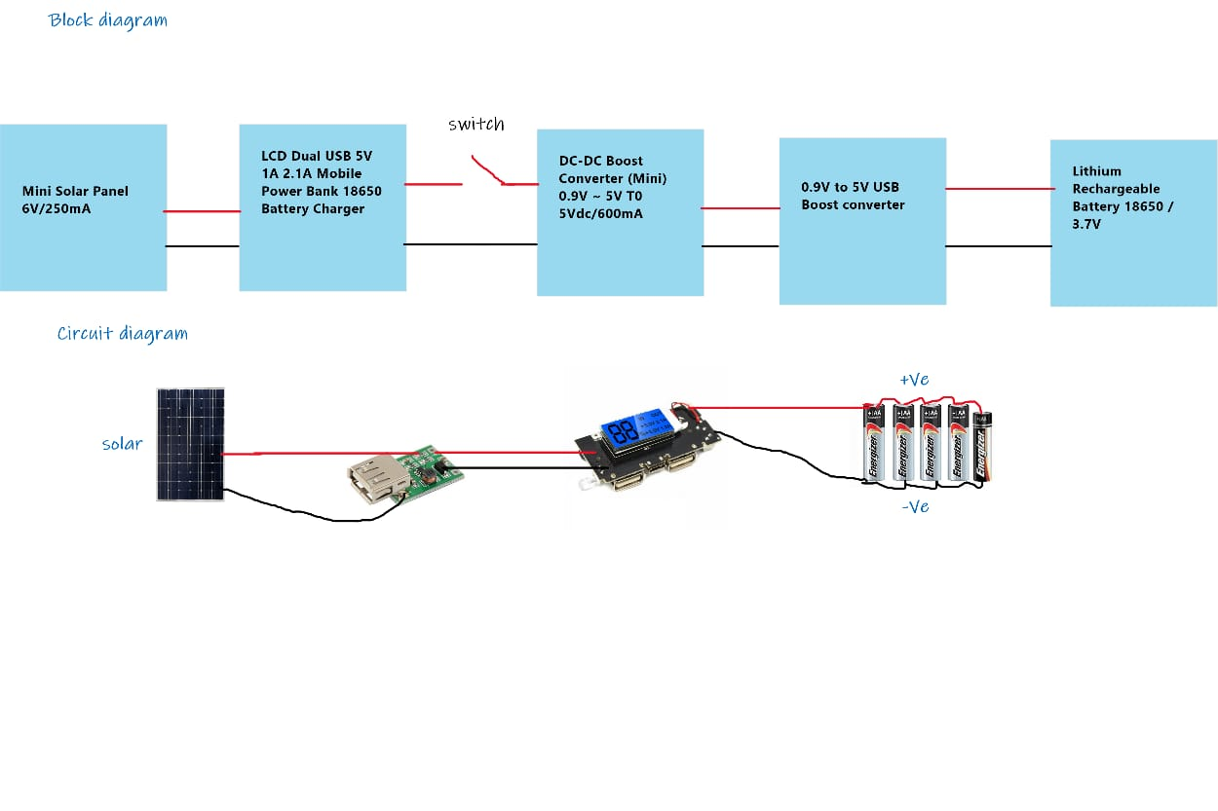

# System Description

Solar panel   
solar panel is simply defined as an assembly of solar cells that can convert light directly into electricity  
At the moment, depending on the type of panel, 5 to 19 % of the light energy can be converted into electricity. This is known as the “output” of the panel. solar panel generates only direct current.

Solar panel Structure  
  
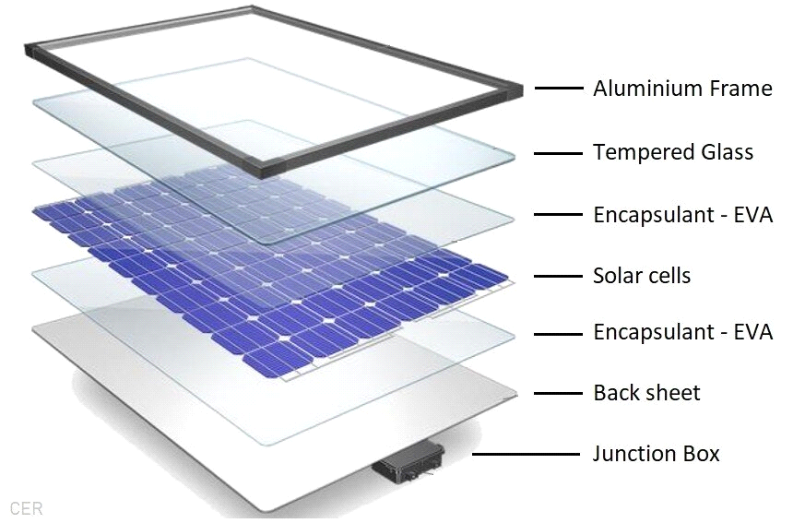  
1. Solar Cells  
  
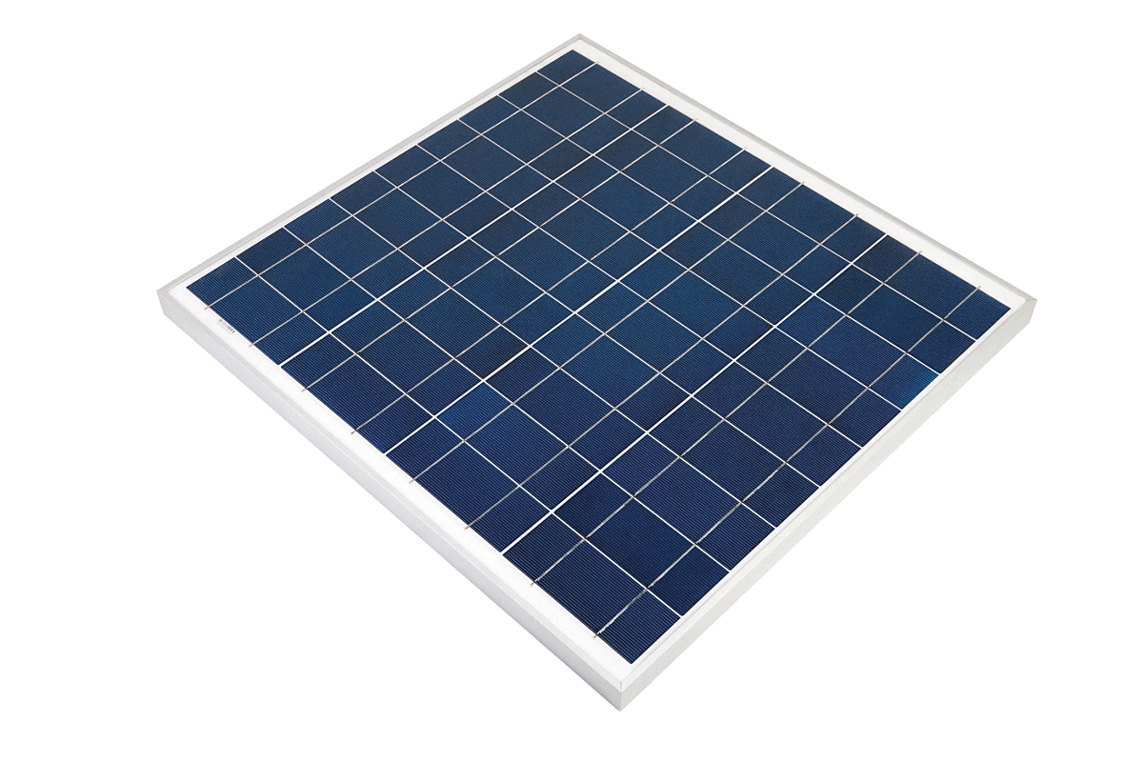

Solar Cell or Photovoltaic (PV) cell is a device that is made up of semiconductor materials such as silicon, gallium arsenide and cadmium telluride, etc. which is used to absorb the sun's rays as when solar cells absorb sunlight, free electrons and holes are created at positive/negative junctions. If the positive and negative junctions of solar cell are connected to DC electrical equipment, current is delivered to operate the electrical equipment (1)  
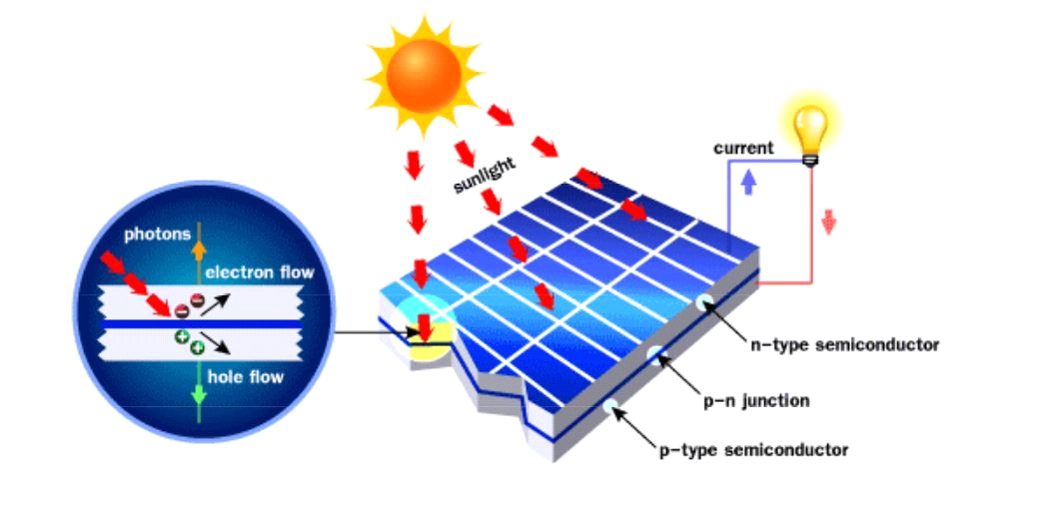

Solar cells as mentioned before are the building blocks of solar panels. Thousands of cells come together to form a solar panel These Solar Cells are stringed together to make Solar Panels which involves soldering, encapsulating, mounting them on a metal frame, etc. providing that the cost and efficiency of solar cells influence the overall performance of the solar panel.  
  
Solar cell types  
There are three major cell types, which are crystalline Silicon, Amorphous Silicon and Hybrid Silicon. but crystalline silicon photovoltaics are considered to be the best type for a solar power bank.  
  
Crystalline silicon photovoltaics is the most widely used photovoltaic technology. they are built using crystalline silicon solar cells (c-Si). Currently, there are two different types of c-Si modules are available: monocrystalline (mono c-Si) and polycrystalline (poly c-Si).These modules are fabricated by joining the c-Si PV cells in series and parallel configurations which are then mechanically assembled by providing the electrical contacts. (2)  
  
  
2. Solar Glass  
 It is the outer most layer on the solar panel, it is made of tempered glass, which is sometimes called toughened glass. There are specific properties that make tempered glass suitable for the manufacturing of solar panels as it is much stronger and is considered safety glass. In case it breaks, it will shatter in thousands of small pieces, that won't be harmful.  
The main function of solar glass is to protect the solar cells from harsh weather, dirt and dust. (3)  
  
3. EVA  
The ethylene vinyl acetate or " EVA " is a highly transparent (plastic) layer used to encapsulate the cells. It provides laminated layering on top of the cells to hold them together. It should be tolerant to withstand extreme temperatures and humidity. (4)  
  
4. Back Sheet  
Back sheet is a film that protects the solar cell from severe environmental conditions. A solar back sheet is the last layer at the bottom of the solar PV panel and is typically made of a polymer or a combination of polymers. it plays a significant role in protecting PV modules, as it protects the solar panels against environmental damage, UV radiations, moisture penetration and ensure that panels remain electrically insulated. (5)  
  
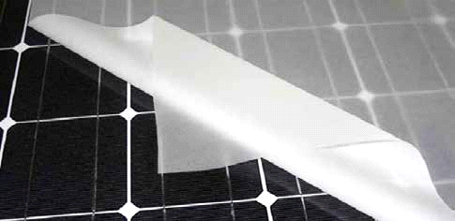  
  
  
5. Aluminum Frame  
Aluminum frame provides structural strength to the panel. It is recommended to use a frame made of strong but lightweight material. It should be stiff and able to withstand extreme conditions like high wind and external forces (6)  
  
6. Junction Box  
The junction box is often an overlooked piece of the solar panel. Usually, pre-installed on the backside of a solar module. most PV junction boxes have diodes. The function of the diodes is to keep the power flow going in one direction, and prevent power from feeding back into the panels when there's no sunshine. also, Junction Box houses all the electric bits on a solar panel and protecting them from the environment. (7)  
  
  
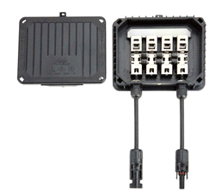

DC Convertor   
DC/DC converters are very essential units that are used in renewable power conversion units as

electronic operating systems for power applications. Most renewable outlets, as well as photovoltaic

(PV) systems and wind energy, have the least voltage output. They demand booster circuits to

provide sufficient voltage at the output side.A boost converter (step-up converter) is a

power converter with an output DC voltage greater than its input DC voltage. It is a class of switching-mode power supply (SMPS) containing at least two semiconductor switches (a diode and a transistor) and at least one energy storage element. Filters made of capacitors (sometimes in combination with inductors) are normally added to the output of the converter to reduce output voltage ripple  
  
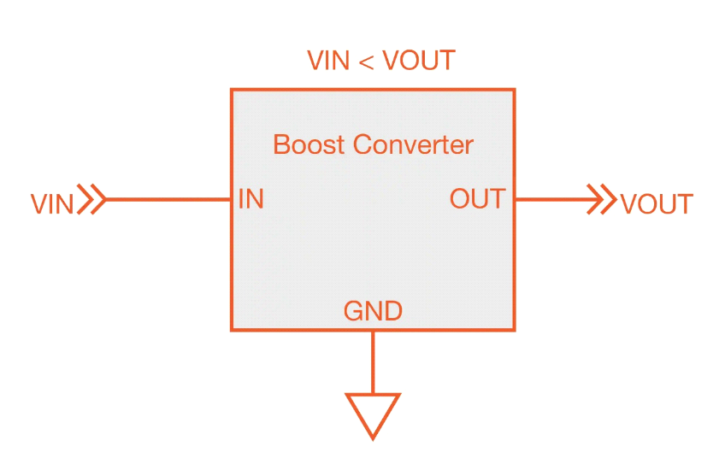

18659 Lithium-Ion Batteries:

An 18650 is a lithium-ion rechargeable battery. Their proper name is “18650 cell”. The 18650 cell has voltage of 3.7v and has between 1800mAh and 3500mAh.

When you click the power switch, you're giving the green light to chemical reactions inside the battery. As the current starts flowing, the cells (power-generating compartments) inside the battery begin to transform themselves and the chemicals from which their components are made begin to rearrange themselves. Inside each cell, chemical reactions take place involving the two electrical terminals (or electrodes) and a chemical known as the electrolyte that separate them. These chemical reactions cause electrons to pump around the circuit the battery is connected to, providing power to the flashlight.

But the cells inside a battery contain only limited supplies of chemicals so the reactions cannot continue indefinitely. Once the chemicals are depleted, the reactions stop, the electrons cease flowing through the outer circuit, the battery is effectively flat. That's the bad news. The good news is that if you're using a rechargeable battery, you can make the chemical reactions run in reverse using a battery charger. (8)

When the cell is given Constant voltage, the cell absorbs the constant current during charging. The cell can absorb as much current as it is given, but providing current more than rated value could reduce battery life or heat up quickly to damage the cell. Lithium-Ion battery charger for a single cell battery is needed, protecting the cell from over and under charging. (9)

## 18650 Battery Charger:

Charging up a battery is the exact opposite of discharging it; where discharging gives out energy, charging takes energy in and stores it by resetting the battery chemicals to how they were originally.

A stand-alone photovoltaic solar energy system connected to batteries requires a charge controller. The charge controller is used to regulate the charging of a battery or battery bank. Without a charge controller, a battery will not charge efficiently and may get ruined due to overcharging or discharging.

All battery chargers have one thing in common: they work by feeding an electric current through batteries for a period of time in the hope that the cells inside will hold on to some of the energy passing through them.

Lithium-Ion chargers first push a constant current until the cell reaches a topping voltage. The charger then keeps a constant voltage, and lets the current freely glide down until a certain “end of charge” threshold is reached. Lithium-ion batteries can become dangerously unstable when the battery voltage is either too high or too low, so they're designed never to operate under those conditions. (10)

These chargers have an inbuilt over charging protection circuit and cut-off circuit that disconnects the battery when it is fully charged, which ensures the long life of the battery and performance.

# Project Hardware AND/OR Simulation.

**Simulation**

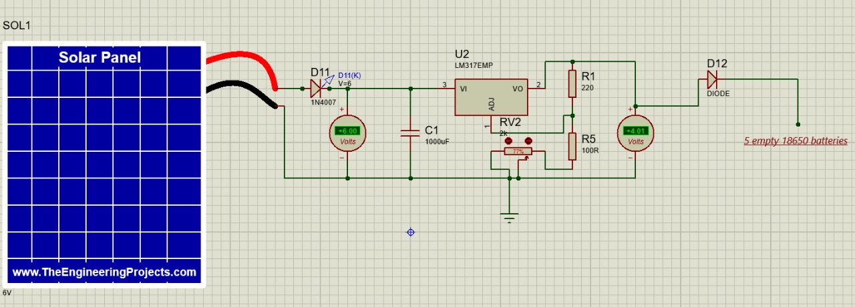

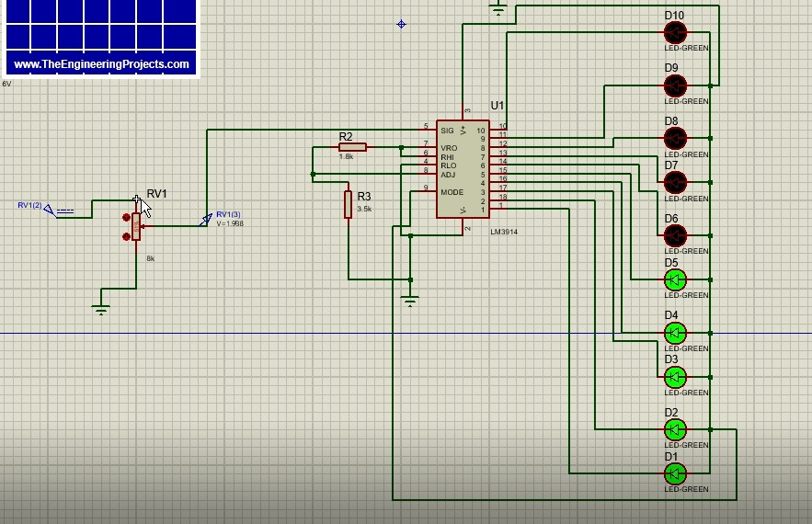

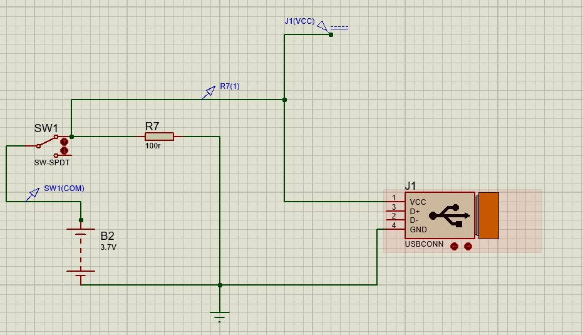

# Components specifications

|  |  |
| --- | --- |
| Component | Specs |
| Mobile Power Bank Battery Charger DIY | * Micro USB input: 5V - 1A * USB Output: 5V - 2.1A / 5V - 1A(Dual USB interface) * Charging display: intelligent digital display * Batteries Type: liquid lithium-ion batteries |
| Mini solar cell | * Rating: 6Vdc/250mA * CELL TYPE: Crystalline Silicon * CELL NUMBER: 12Cells * OPERATING TEMP: -20 ~ +60 C |
| DC-DC Boost Converter | * Output Current: Rated 0.6A * Type: DC/DC Converters * Input Voltage: 0.9 to 5 Vdc * Output Voltage: 5.1-5.2 Vdc * Efficiency: Up to 96% * Switching frequency: 500KHz * Voltage indication: LED lights with load * Operating Temperature: Industrial (-40 deg C to +85 deg C) * Output: USB Output |
| 5x Lithium Rechargeable Battery | * 3.7V 18650 22000mAh (Actual ~ 1500mAh) Li-ion Rechargeable Battery |

# Project specifications

**Batteries type:** liquid lithium-ion batteries (18650)

**Total battery capacity:** 7500mah

**Input**: 5V 1A (micro-USB)

**USB output:**

Out1: 5V 1A

Out2: 5V 2.1A

**Operating temp**: -20 ~ +60 C

# References

1. **Basics of Solar Cell. *leonics.* [Online] https://www.leonics.com/support/article2_13j/articles2_13j_en.php.**

**2. Solar PV module technologies. *sciencedirect.* [Online] https://www.sciencedirect.com/topics/engineering/crystalline-silicon-module.**

**3. Solar Glass: applications and comparison to Light-Trapping. *sinovoltaics.* [Online] https://sinovoltaics.com/learning-center/materials/solar-glass-applications-and-comparison-to-light-trapping/.**

**4. What are the Main Components of a Solar Panel? *loomsolar.* [Online] https://www.loomsolar.com/blogs/collections/solar-panel-components.**

**5. BACKSHEETS Selecting the Right Materials for Solar Modules & EVA. *saurenergy.* [Online] https://www.saurenergy.com/solar-energy-articles/backsheets-selecting-the-right-materials-for-solar-modules-eva.**

**6. What are the Main Components of a Solar Panel? *loomsolar.* [Online] https://www.loomsolar.com/blogs/collections/solar-panel-components.**

**7. PV Junction Box: purpose and connection. *sinovoltaics.* [Online] https://sinovoltaics.com/learning-center/materials/pv-junction-box-purpose-and-connection/.**

**8. Battery chargers. *explainthatstuff.* [Online] https://www.explainthatstuff.com/how-battery-chargers-work.html.**

**9. 18650 Battery How to Charge – 5 Simple Solutions. *somanytech.* [Online] https://somanytech.com/18650-battery-how-to-charge-18650-battery-with-charger-and-without-charger/.**

**10. Lithium ion Solar Charge Controller Guide. *zhcsolar.* [Online] https://zhcsolar.com/lithium-ion-solar-charge-controller/.**